**[SOLVED] How to Resolve Error 8614**

I ran into this issue with two Domain Controllers that would not replicate.  DC2 was getting this error: ***"The Active Directory cannot replicate with this server because the time since the last replication with this server has exceeded the tombstone lifetime"***  
  
Below are the steps I went through in order to remedy this situation and worked like a charm.

**1. Verify which Domain Controller raised the 8614 error by using:**  
  
***> repadmin /showrepl***  
or  
***> repadmin /showreps***  
  
* Run this command line in any DC not DC-A.  
  
* In addition, open **Event Viewer**, in **Applications and Services Logs**, **Directory Service**, you will see an error with **event ID 2042**

[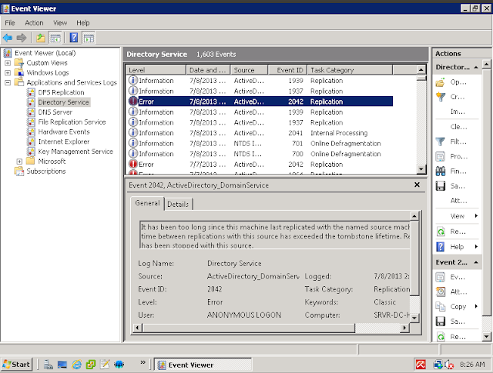](https://4.bp.blogspot.com/-LxoJaJOdvDs/Udy5HFlmFLI/AAAAAAAABlI/qbMGGlbiD-8/s1600/Screenshot+from+2013-07-10+08:23:56.png)

According to Mirosoft knowledge base, it's maybe because the domain controller contains what so called lingering objects: <http://support.microsoft.com/kb/2020053>. This is the most possible reason for the error, because everything else are OK (time, default tombstone lifetime).  
  
  
**2. So, I have to remove those lingering objects from all DCs:**

***> repadmin /removelingeringobjects DC-A.MYDOMAIN.COM 5b0b944e-de7b-4f96-942b-1e040169db36 "CN=Configuration,DC=MYDOMAIN,DC=COM"***  
  
+ DC-A.MYDOMAIN.COM : FQDN of DC-A  
  
+ 5b0b944e-de7b-4f96-942b-1e040169db36 : the GUID of DC-A. You can get it from the command repadmin /showrepl DC-A.  
  
+ "CN=Configuration,DC=MYDOMAIN,DC=COM": NC in which DC-A raise the error (from the output of the command repadmin /showrepl)  
 **\* Repeat in all other DCs in forest.**  
  
  
**3. Evaluate setting strict replication on all DCs in forest:**  
  
***> repadmin /regkey * +strict***  
  
  
**4. Set "Allow replication with divergent and corrupt partner = 1" on all DCs:**  
  
**> repadmin /regkey * +allowDivergent**  
  
  
**5. Flush DNS Cache and restart netlogon service in DC-A:**  
  
+ ***> ipconfig /flushdns***  
  
+ ***> net stop netlogon***  
  
+ rename netlogon.dns and netlogon.dnb file which locate in C:\Windows\System32\  
  
+ ***> ipconfig /flushdns***  
  
+***> net start netlogon***(this command will re-create netlogon.dns and netlogon.dnb files)  
  
+ ***> ipconfig /registerdns***  
  
  
**6. Check the replication of all DCs again using repadmin and Event Viewer**  
  
***> repadmin /showrepl***  
  
  
**7. Delete "Allow replication with divergent and corrupt partner" or set "Allow replication with divergent and corrupt partner = 0" in the registry of all DCs.**  
  
***> repadmin /regkey * -allowDivergent***  
  
  
**8. Check the replication of all DCs again using repadmin and Event Viewer**  
  
  
If you performed everything correctly, the Domain Controllers will now replicate successfully.

Posted by [Will](https://www.blogger.com/profile/14235491142723420180)at [3:39 PM](https://itthatshouldjustwork.blogspot.com/2017/03/solved-how-to-resolve-error-8614.html) [[](https://www.blogger.com/email-post.g?blogID=7425517&postID=8629584363805871511)](https://www.blogger.com/email-post.g?blogID=7425517&postID=8629584363805871511)[](https://www.blogger.com/post-edit.g?blogID=7425517&postID=8629584363805871511&from=pencil)

Labels: [Active Directory](https://itthatshouldjustwork.blogspot.com/search/label/Active%20Directory), [Domain Controller](https://itthatshouldjustwork.blogspot.com/search/label/Domain%20Controller)